Specular light

📘 Definition
# Source: AI Source: Provided by: [Data Path: Persons Table -> ID Column: 1, Name_En Column: Motasem Essam] -> From: [ChatGPT] on [5/2/2026]
Specular light is the part of light that creates bright, shiny highlights on a surface when light reflects in a focused direction.
It is what makes objects look glossy, polished, or reflective.

✨ How specular light works
# Source: AI Source: Provided by: [Data Path: Persons Table -> ID Column: 1, Name_En Column: Motasem Essam] -> From: [ChatGPT] on [5/2/2026]
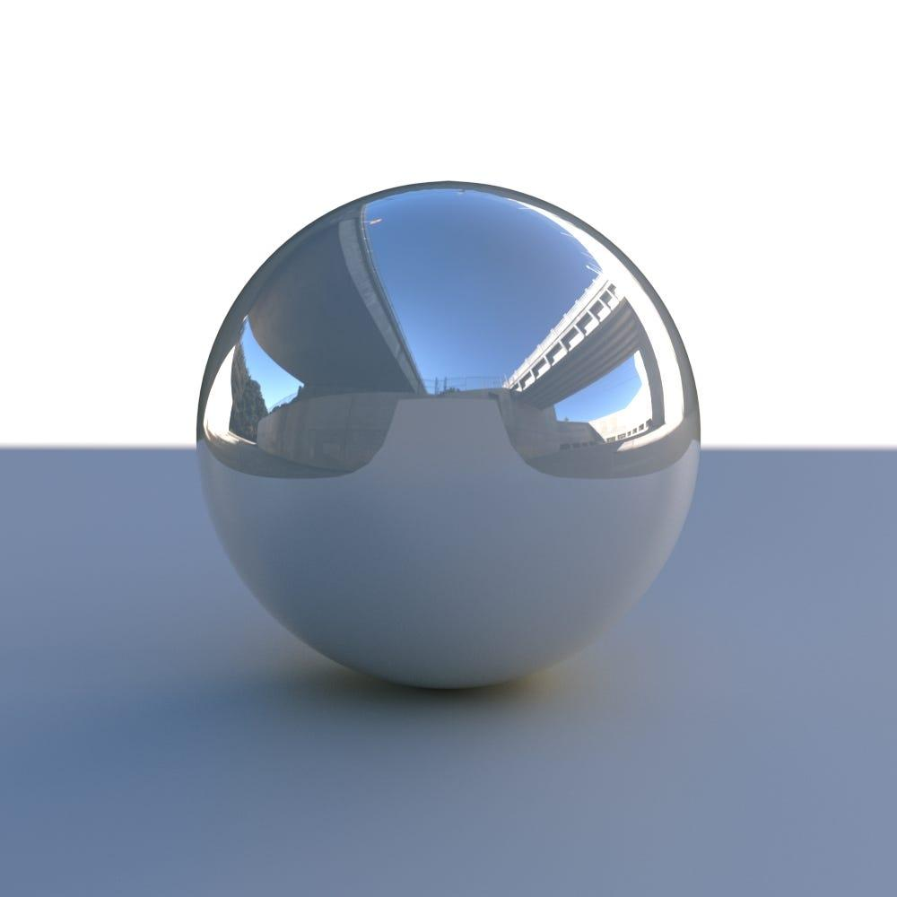

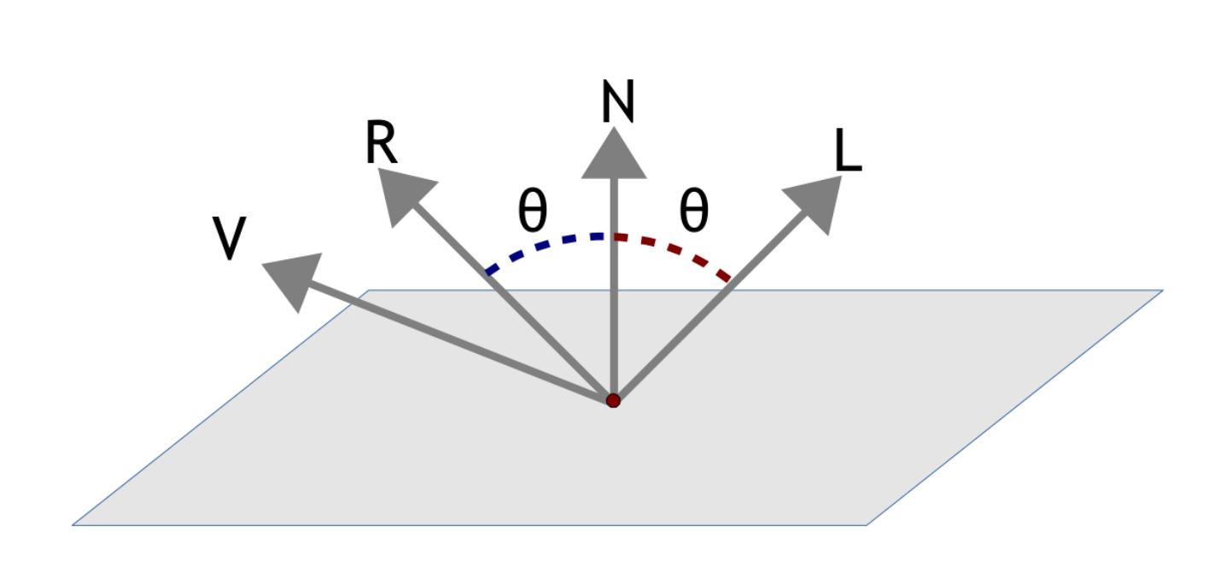
- Light hits a smooth surface
- It reflects in a specific direction
- If that reflection reaches your eyes → you see a bright highlight
- This bright spot is called the specular highlight

🧠 Simple example
# Source: AI Source: Provided by: [Data Path: Persons Table -> ID Column: 1, Name_En Column: Motasem Essam] -> From: [ChatGPT] on [5/2/2026]
Think of:
- 🪞 A mirror → very strong specular reflection
- 🪙 A polished metal coin → shiny spot on the surface
- 💧 Water under sunlight → sparkling highlights

🎮 Specular light in computer graphics
# Source: AI Source: Provided by: [Data Path: Persons Table -> ID Column: 1, Name_En Column: Motasem Essam] -> From: [ChatGPT] on [5/2/2026]
Specular light is used to:
- Create shiny surfaces (metal, glass, plastic)
- Add realistic highlights in 3D objects
- Show light direction clearly
- Improve realism in games and animation

⚙️ Key features
# Source: AI Source: Provided by: [Data Path: Persons Table -> ID Column: 1, Name_En Column: Motasem Essam] -> From: [ChatGPT] on [5/2/2026]
- ✨ Produces bright highlights (glossy spots)
- 🪞 Happens on smooth surfaces
- 🎯 Depends on viewer position (camera angle)
- 🌟 Makes objects look shiny and realistic

🚀 In short:
# Source: AI Source: Provided by: [Data Path: Persons Table -> ID Column: 1, Name_En Column: Motasem Essam] -> From: [ChatGPT] on [5/2/2026]
Specular Light = light that creates bright shiny highlights on smooth surfaces when reflected directly toward the viewer.

